# Table of contents

**1. Login** **1**

**2. Logout** **1**

**3. Add new book** **1**

**4. Update a book** **1**

**5. Delete a book** **1**

**6. Change order status** **1**

**7. Add new voucher** **1**

**8. Delete voucher** **1**

# 

# Login

Login as an admin is the same as login as a customer. The username and password is “root” and “root”. The interface after logging in as an admin as below:

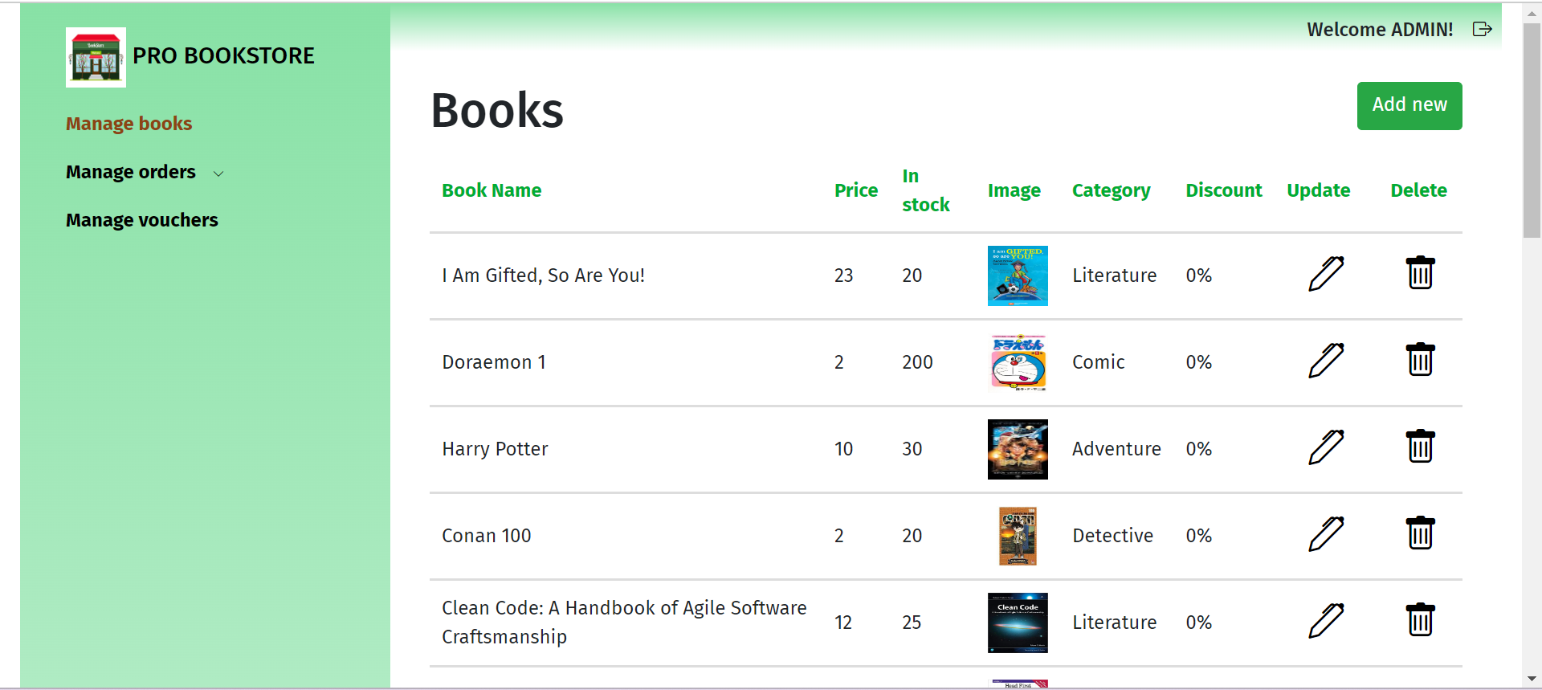

# Logout

Click the icon at top right corner of the page to logout:

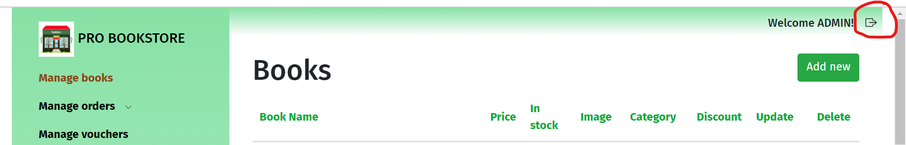

# Add new book

Click “Add new” button to redirect to add new book form page:



Then enter enough inputs to add a new book, then click “Add book” button:

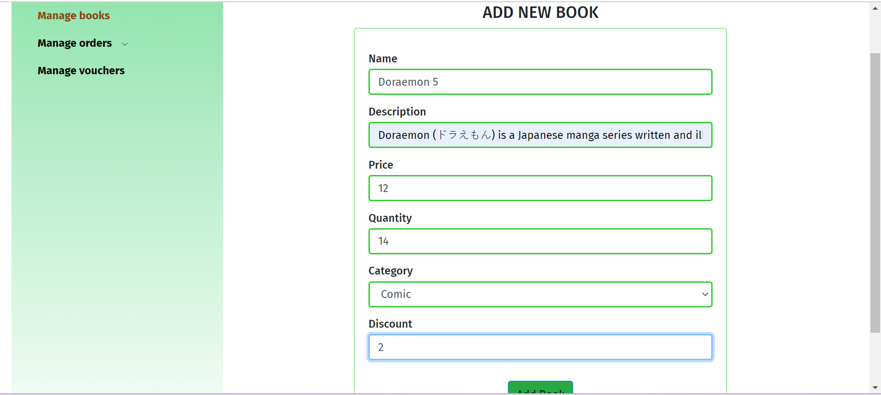

# Update a book

Click the pencil icon to redirect to update a book page

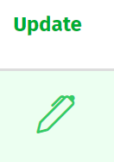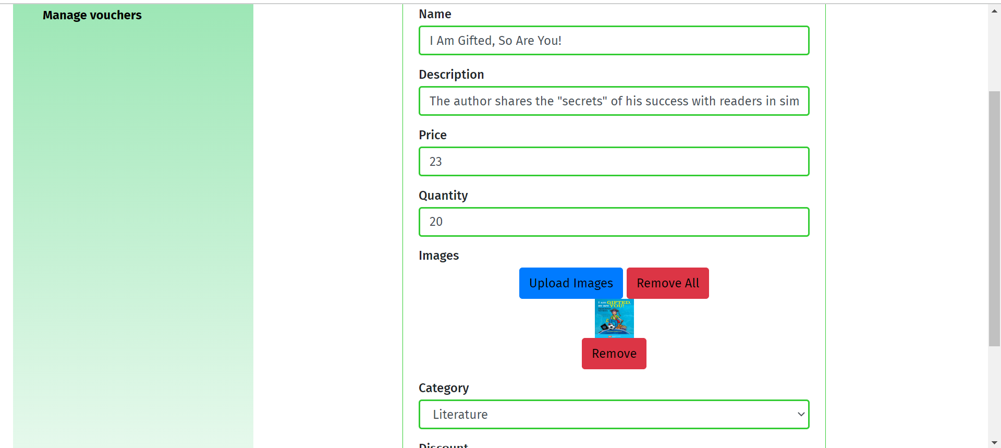

Update information, then click “Update book” button at the bottom of the page

# Delete a book

Click bin button to delete a book:

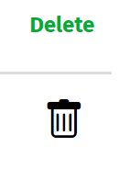

# Change order status

Hover “Manage orders” and click one order status to manage order:

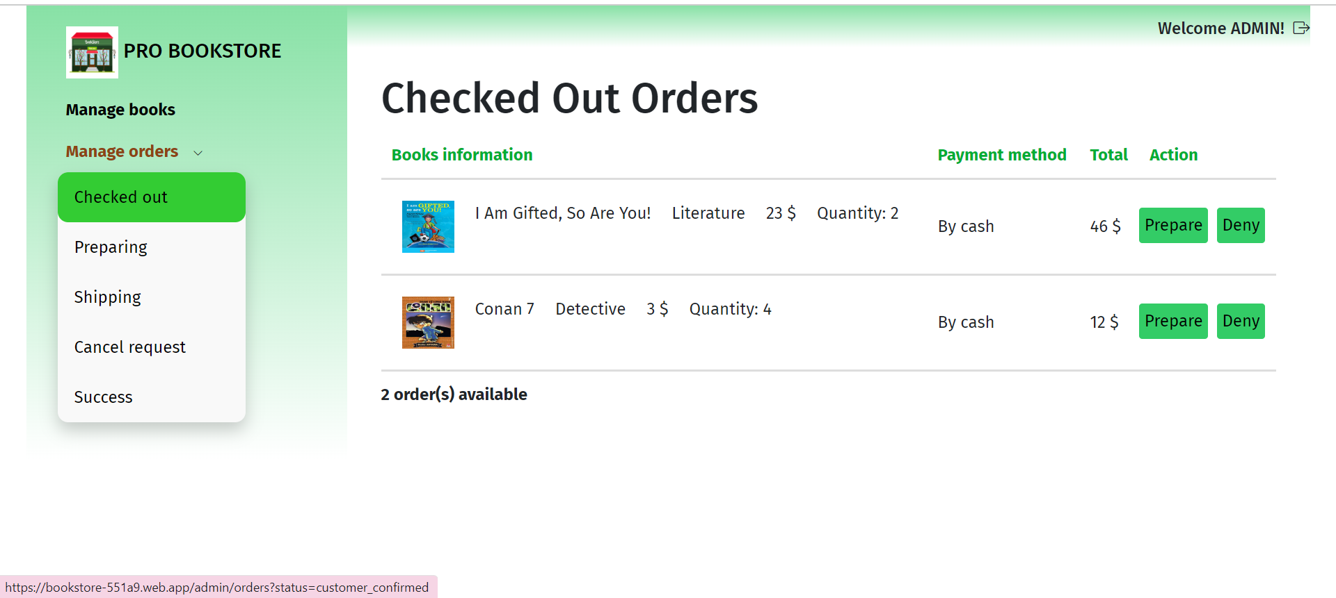

Click buttons to change status such as “Prepare” or “Deny” order as above

# Add new voucher

Click “Add new” button to redirect to add new voucher page:

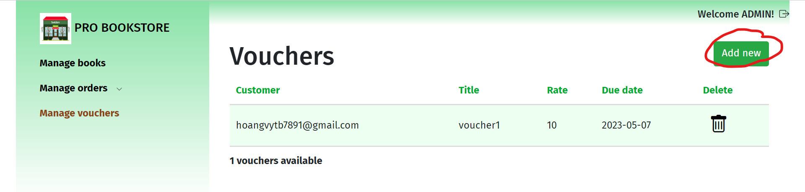

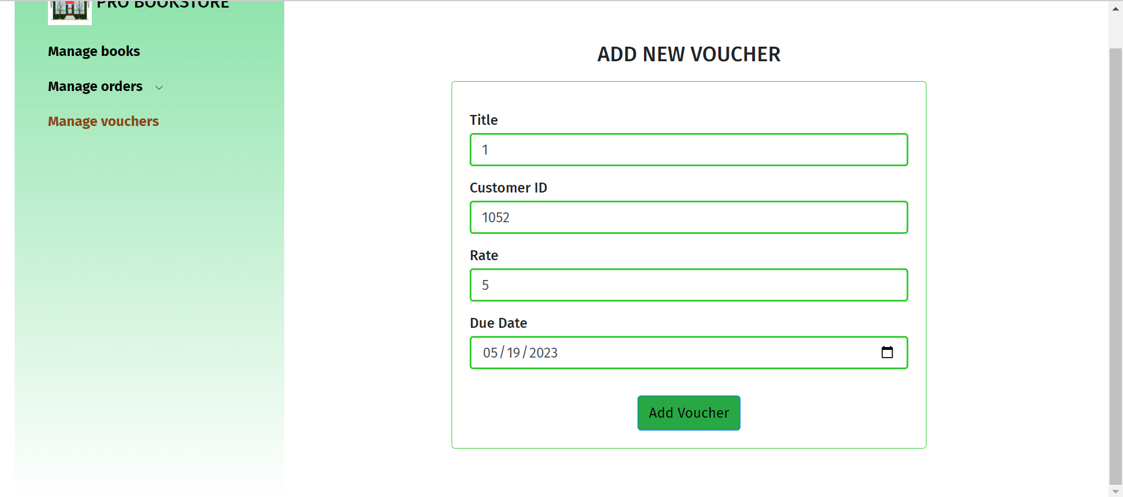

Enter enough inputs to add new voucher to corresponding customer

# Delete voucher

Click bin button to delete a book:

